Name ____________________________

Skill 76: Use formulas to find the volume of prisms and cylinders.

Find the volume of each solid to the nearest tenth. (use = 3.14)
Circle the correct answer.
a. 76, 517  b. 133.3  c. 2,186.2  d. 4,436.7 | a. 490.05  b. 254.025  c. 44.55  d. 54.45 | - 3,309.56  - 194.68  - 53.38  - 1,654.78
  1. | 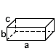
    a = |  | 64.3 in
    b = |  | 34 in
    c = |  | 35 in
  2. | 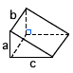
    a = |  | 4.95 ft
    b = |  | 9 ft
    c = |  | 11 ft
  3. | 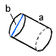
    a = |  | 17 m
    b = |  | 62 m
- 188.40  - 9.42  - 565.2  - 376.8 | a.1962.5  b. 785  c. 382,5  d. 250 | - 4,634.784  - 137.94  - 406.56
  4. | 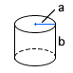
    a = |  | 3 cm
    b = |  | 20 cm
  5. | 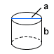
    a = |  | 10 yd
    b = |  | 25 yd
  6. | 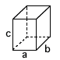
    a = |  | 11.4 km
    b = |  | 12.1 km
    c = |  | 33.6 km

Find the volume of each solid to the nearest tenth. (use = 3.14)
Show your work.
 | 7.
  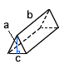
  a = |  | 2.17 m
  b = |  | 12 m
  c = |  | 12 m
  8.
    a = |  | 8.1 ft
    b = |  | 18.7 ft
11. |  | 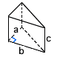 | 9.
  a = |  | 7.05 yd
  b = |  | 8 yd
  c = |  | 13 yd
  a = |  | 36 cm
  b = |  | 61 cm

