Name ____________________________

Skill 75: Use formulas to find circumference and area of a circle.

Find the circumference of the circles below. Use 3.14 for .

 | - 175.84in  - 112in  - 351.68in  - 56
  1. | - 207.24cm  - 103.62cm  - 66cm  - 33cm
    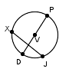
       | = | 66 | cm
        PD
  2.
    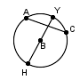
       | = | 56 | in
        HB

Find the circumference. Show your work in the space below. Write the answer on the line. Use 3.14 for .
 | ___________
  3. | ___________
    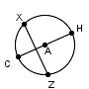
       | = | 29 | ft
        AC
  4.
    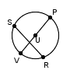
       | = | 17 | mm
        UP

Find the Area of the circles below. Use 3.14 for .

a. 18,617.06mm  b. 241.78mm  c. 4,654.265mm  d. 120.89mm
  5.
    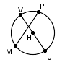
       |  | = | 77
        UV
      mm
  6. | - 1808.64cm  - 576cm  - 7,234.56cm  - 150.72cm
    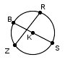
       | = | 48 | cm
        BS

Find the Area of the circles below. Use 3.14 for . Show your work and write you answer on the line provided.

 | __________
  7. | __________
    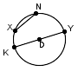
       | = | 62 | ft
        YK
  8.
    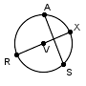
       | = | 16 | in
        VX

9. What is the area of a circle with a diameter 11 meters?
Leave your answer in terms of .

a. 11
b. 22
c. 121
d. 5.5

10. What is the area of a circle with a radius of 10 feet. Leave your answer in terms of .

- 10
- 5
- 25
- 100

