Skill 73: Solve and explain simple one-step equations using inverse operations involving whole numbers

Solve each one-step pan balance problem below.
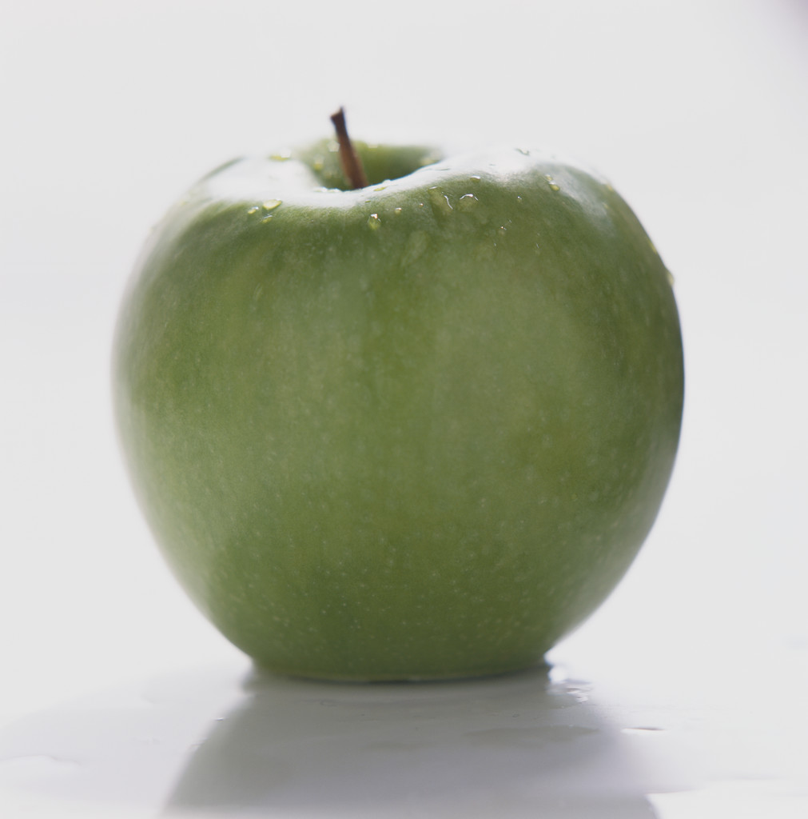

1.One apple weighs as much as ______ marbles. 2.One orange weighs as much as ______ marbles.

Find the value of each letter in the problems below. Write the answer on the line below each of the problems.

e = | h = | q =
  3.
    e + 18 | = | 85
  4.
    88 + h | = | 147
  5.
    82 | = | q + 30

d = | b = | m =
  6.
    69 | = | 95 - d
  7.
    4b | = | 36
  8.
    10 | = | 2m

t = | u =
  9.
    60 | = | t - 18
  10.
    22 | = | u - 33

