Name ____________________________

Skill 70: Use a formula to find the area of triangles and parallelograms.

For each of the problems below write the answer on the line below each problem.

Find the area of each parallelogram.
  1.
    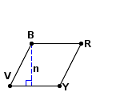 | n = 18 mm
       | = | 20 mm
        BV
       | = | 21 mm
        BR
  2.
    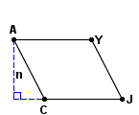 | n = 62 ft
       | = | 81 ft
        AY
       | = | 70 ft
        AC

_______________________________________ ___________________________________

Find the area of each parallelogram. Round to the nearest tenths.
  3.
    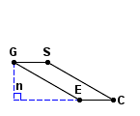 | n = 16.4 ft
       | = | 32.8 ft
        CS
       | = | 14.7 ft
        EC
  4.
    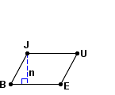 | n = 3.5 cm
       | = | 3.9 cm
        JB
       | = | 5.6 cm
        JU

______________________________________ ____________________________________

Find the area of each triangle.
  5.
    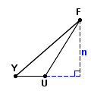 | n = 16 in
       | = | 19 in
        UF
       | = | 9 in
        YU
       | = | 25 in
        YF
  6.
    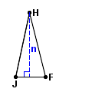 | n = 59 cm
       | = | 27 cm
        JF
       | = | 60 cm
        JH
       | = | 61 cm
        FH

_______________________________________ ____________________________________

Find the area of each triangle. Round your answer to the nearest tenth.
  7.
    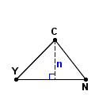 | n = 2.5 in
       | = | 4.4 in
        YN
       | = | 3.5 in
        YC
       | = | 3.2 in
        NC
  8.
    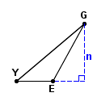 | n = 7.1 cm
       | = | 8.1 cm
        EG
       | = | 11 cm
        YG
       | = | 4.5 cm
        YE

_______________________________________ ____________________________________

- Jesse wants to buy glass for his new attic window that is in a shape of an equilateral triangle. He measures one of the sides and it is about 2 ft long. He measure the height of the triangle and it is 2.5ft long. How much glass fit into that window?
        - 5 ft
        - 4 ft
        - 2.5 ft
        - 2 ft

10) Find the area of the parallelogram below.
5ft

4.5 ft 6 ft

- 30ft
- 22.5ft
- 27ft
- 135ft.

