Name ____________________________

Skill 67: Use a formula to find the area of rectangles.

Find the Area of each of the figures

  1.
    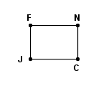
       | = | 16 cm
        JF
       | = | 22 cm
        FN
  2.
    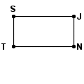
       | = | 123 yd
        SJ
       | = | 61 yd
        JN
  3.
    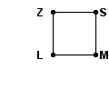
       | = | 19 ft
        ML
       | = | 19 ft
        LZ
  4.
    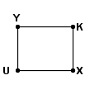
       | = | 176 m
        YK
       | = | 139 m
        KX
  5.
    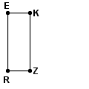
       | = | 195 cm
        RE
       | = | 75 cm
        EK
  6.
    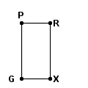
       | = | 133 mm
        XG
       | = | 258 mm
        GP
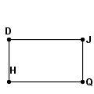
- Find the area of the rectangle below.

3cm

7cm

- 21cm
- 20cm
- 42cm
- 12cm

- Find the area of the football field below
32ft a.
b.7,168 ft
224ft c.
d.

- John wanted to plant his cabbage in his garden. He measures the plot and finds that on side is about 6.5ft long and the other side is 8.9ft long. What is the area of his cabbage plot?
        - 57.85ft
        - 15.4 ft
        - 30.8ft
        - 48 ft

- Megan wanted to put carpet in her bedroom that is shaped like a square. She measures one side and finds out that it is 12 ft long. How much square feet must she buy in order to cover the floor in her bedroom?
        - 144 ft²
        - 48 ft²
        - 24 ft²
        - 576 ft²

