Name ____________________________

Skill 65: 9d. Identify and Plot ordered pairs on a one-quadrant coordinate grid.

Write the ordered pair for each point.

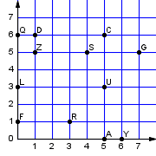
  1) F | _______
  2) L | _______
  3) Z | _______
  4) D | _______
  5) U | _______

Plot the ordered pair for each of the points on the grid below. Make sure to label each point as the specific letter.

- A = (5, 2)

- B = (6, 2)
- C = (7, 3)

- D = (2, 4)

- E = (2, 5)

