11d: Estimate and weigh objects in ounces and grams.

Circle the best Estimate.

  1.
    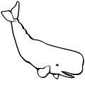
    67,382 pounds | 67,382 ounces
  2.
    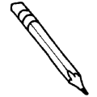
    1 ounce | 1 pound
  3.
    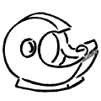
    2 ounces | 20 ounces
  4.
    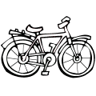
    220 pounds | 44 pounds
  5.
    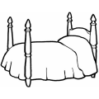
    95 pounds | 9 ounces
  6.
    2 kilograms | 26 kilograms
  7.
    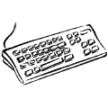
    20 grams | 2 kilograms
  8.
    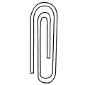
    29 grams | 1 gram
  9.
    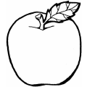
    130 kilograms | 130 grams
  10.
    31,703 kilograms | 3 kilograms

