9d: Give equivalencies between 'easy' fractions and percents

Write each fraction as a percent.

  1.
    25
    100
  2.
    47
    100
  3.
    64
    100
  4.
    8
    100
  5.
    58
    100

____________ ___________ ___________ ___________ ____________

Write the percent for each of the shaded parts.

  7. | 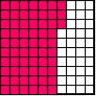
  8. | 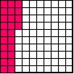
  9. | 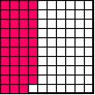

________________ _________________ ________________

Write the Percent for the unshaded parts.

  10. | 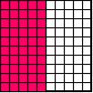
  11. | 

 

