9c: Find a percent or fraction of a number

Write the percent and fraction of each of these wholes.
  1. | 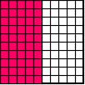
  2. | 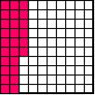
  3. | 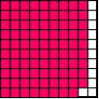

____________________ ___________________ __________________

  4. | 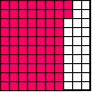
  5. | 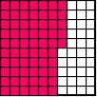
  5. | 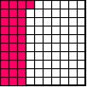

____________________ ___________________ __________________

Circle the correct answer that matches the shaded portion of the picture below.

a. 53%  b. 46%  c. 50%  d. 55% | a. 93/100  b. 93/10  c. 9/3  d. 6/100 | a. 3/100  b. 4/100  c. 40/100  d. 4/10
  6. | 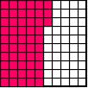
  7. | 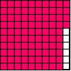
  8. | 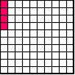

10. What is ¾ of 40?

- Write the answer as a percent: _________________________

