8c: Find the perimeter of a polygon

Find the perimeter of the triangles below:

35 in.
2 ft
2 ft
25 in.

25 in.
2 ft

1) Answer: ________ feet 2) Answer: _________ inches

Find the perimeter of the polygons below:

3.
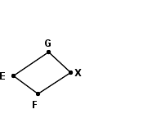 | Polygon FXGE:
   | = | 80 in
    FX
   | = | 62 in
    XG
   | = | 87 in
    GE
   | = | 62 in
    EF

4.
  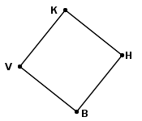 | Regular polygon VKHB:
     | = | 54 ft
      BV
Answer: ________________________ Answer:____________________

Answer:__________________
5.
  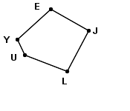 | Polygon UYEJL:
     | = | 18 mm
      UY
     | = | 47 mm
      YE
     | = | 46 mm
      EJ
     | = | 48 mm
      JL
     | = | 47 mm
      LU

