8b: Use formulas to find areas of rectangles/parallelograms/triangles.

Find the area of each figure.

  1.
    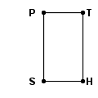
       | = | 32 yd
        PT
       | = | 56 yd
        TH
  2.
    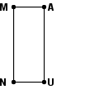
       | = | 90 m
        UN
       | = | 222 m
        NM
Circle the correct answer: Show your work and write the answer
- 1,792 yd below:
- 88 yd
- 175 yd
- 1,790 yd ________________________________

  3.
    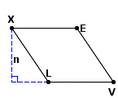 | n = 40 in
       | = | 48 in
        XL
       | = | 48 in
        XE
  4.
    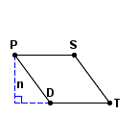 | n = 50 ft
       | = | 62 ft
        TS
       | = | 62 ft
        DT
Circle the correct answer: Show your work and write the answer
below:
- 1,920 in.
- 2,304 in.
- 88 in.
- 96 in. ________________________________

  5.
    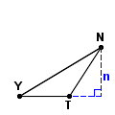 | n = 45 cm
       | = | 53 cm
        TN
       | = | 87 cm
        YN
       | = | 46 cm
        YT
  6.
    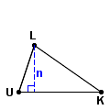 | n = 28 mm
       | = | 30 mm
        UL
       | = | 49 mm
        KL
       | = | 50 mm
        UK
Circle the correct answer: Show your work and write the answer
below:
a. 2,385cm
- 2,070cm.
- 1,036cm.
- 4,002 ________________________________

