7h: Identify fractional parts of a region.

1) Show ½ of an hour on a clock face. 2) Show 1 ½ hours on the clock faces.

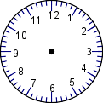

3) Show ¼ of an hour on a clock face. 4) Show ¾ of an hour on a clock face.

5) Show 2/3 on the clock face.

