6g Make turns and fractions of turns

Question 1:
Which of these shows this figure turned ½ turn?


Choose One:
 |  |  |  |  |  |  | 

Question 2:
Which of these shows this figure being rotated to the right?
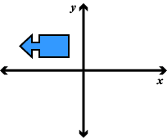

Choose One:
 | 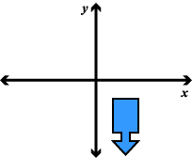
  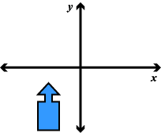

Question 3:
Which picture shows a rotation from Figure A to Figure B?
Choose One:
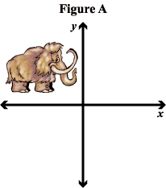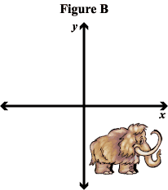
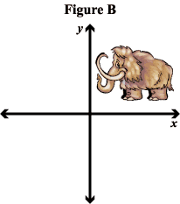
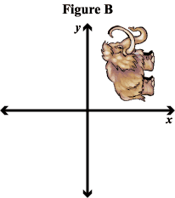

4) Which of the pictures below shows ½ rotated?

a) b) c) d)

5) Which of the pictures below show ¾ rotated?

a) b) c) d)

6) Which of the pictures below show ½ rotated?

a) b) c) d)

7) Name the turn on the line below in fraction form.

___________

___________

