6f Identify acute, right, obtuse, straight and reflex angles.

a. YMT  b. YMN  c. MNT  d. MYN | a. ZML  b. LMF  c. FMZ  d. FLT | a. QCF  b. LFQ  c. QFC  d. LFC
  1. | 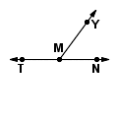  Name the acute angle.
  2. | 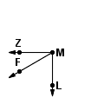  Name the right angle
  3. | 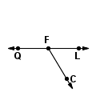  Name the obtuse angle
a. EGH  b. EGB  c. EGQ  d. EGH | a. BTG  b. ZTB  c. ZTG  d. GBT | a. HFC  b. HFP  c. CFP  d. LFC
  4. | 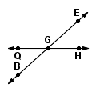  Name the straight angle.
  5. | 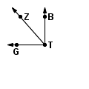  Name the acute angle.
  6. | 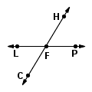  Name the obtuse angle.

7. Explain what defines a right angle?

8. Explain what defines an obtuse angle?

9. Explain what defines an acute angle?

10 Explain what are reflex angles?

