6e Name and locate points specified by ordered number pairs.

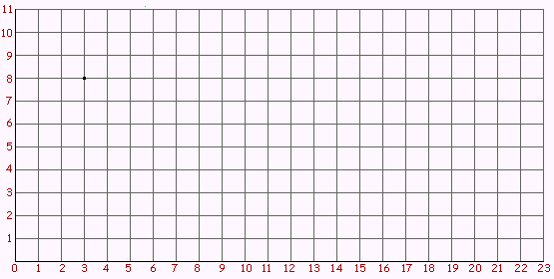

Write the ordered pair for each of the shapes above.

1) White circle (_____,_____)

2) Triangle (_____,_____)

3) Hexagon (_____,_____)

4) Square (_____,_____)

5) Heart (_____,_____)

Bonus: Draw a hexagon on the grid located at ( 20, 10)

