4i: Use dollars-and-cents notation

Count the total number of coins and write it in decimal form.

  1. | 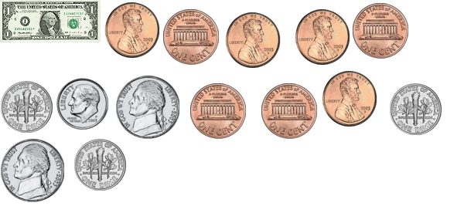  ____________________
  2. | 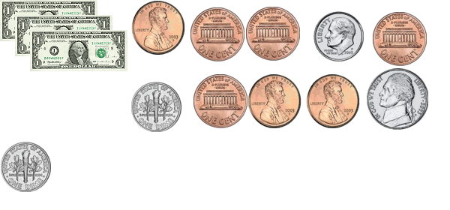  ____________________
  3. | 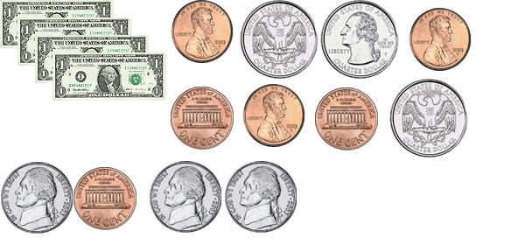  ____________________
  4. | 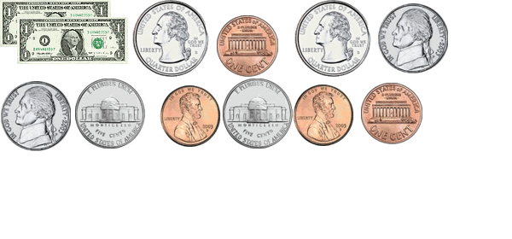  ____________________
  5. | 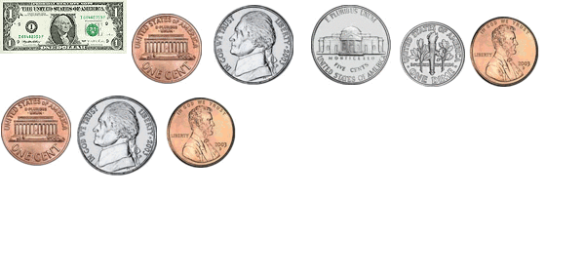  ____________________
  6. | 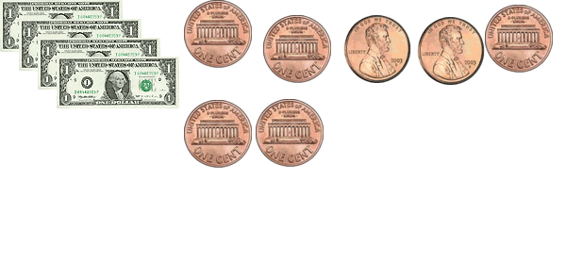

Write the total amount that each person has in decimal form.

- John has five pennies, six dimes, four quarters and 3 nickels. __________

- Sarah has two pennies, five dollar bills, six half dollars and seven dimes. ______

- Afi has nine quarters, two pennies and seven nickels. ________

- Jeff has two dimes, three quarters and five pennies. ________

