4N10 | Decimals as parts of a whole

Write the decimal.

  1. | 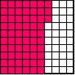
  2. | 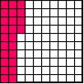
  3. | 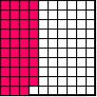

_____________________ _____________________ _______________________

4) What is the decimal for the unshaded part of the whole?

- 0.30
- 0.03
- 0.07
- 0.70

5) What is the decimal for the shaded part of the whole.

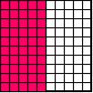

- 5.00
- 0.50
- 0.05
- 0.5

