2c: Use the statistical landmarks maximum and minimum

Use the numbers below to answer questions 1-4

1, 4, 4, 5, 5, 6, 6, 6, 6, 7, 7, 8, 8, 8, 9

1. What is the maximum of that set of data?___________________________

2. What is the minimum of that set of data?___________________________

3. Define Maximum:________________________________________________________________________________________________________________________________________________________________________________________

4. Define Minimum:________________________________________________________________________________________________________________________________________________________________________________________

Use the graph below to answer questions 5 and 6.

School Play Attendance
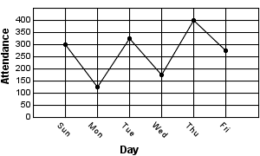
5) What is the maximum number of people who attended the school play on a given day?

a. 300
b. 450
c. 275
d. 325

6) What day did they have the minimum number of people?
a. Thursday
b. Tuesday
c. Wednesday
d. Monday
Use the frequency table below to answer questions 7-8

Ms. Yang’s Heights.
Name | Height in cm.
Jason | 123
Meg | 129
Rhonda | 129
Barry | 137
Todd | 142
Carolyn | 108

7) What was the maximum of the class height data?:________________

8) What was the minimum of the class height data?:_________________

Use the data below to answer questions 9-10

Ms Yang’s class voted on which snack was their favorite. The tally chart below shows their results.
Favorite Snack
Snack | Number
Popcorn
Gum
Crackers
Nachos
Ice Cream
Pretzels

9) Which snack had the maximum number of votes? _____________________

10) Which snack had the minimum number of votes? _____________________

