4S5 Make predictions using data

Probability

1. | A bag contains 3 yellow marbles, 18 blue marbles, 5 purple marbles, 8 red marbles, and 10 green marbles. What is the probability of pulling out a green marble?

- likely
- unlikely
- impossible
- certainly

2. | A number cube has 6 sides. The sides are numbered 1 to 6. If the cube is thrown once, what is the probability of rolling the number 1 or the number 6?

- likely
- unlikely
- impossible
- certainly

3.
  The following coins are put in a bag:
  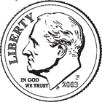
  Describe the probability of picking a penny.

- likely
- unlikely
- impossible
- certainly

4.
  A glass jar contains a total of 34 marbles. The jar has red and blue marbles. There are 27 red marbles. Describe the probability of picking a red marble.

- likely
- unlikely
- impossible
- certainly
Data Predictions.

Use the bar graph to answer the questions below.

1) Look at the horizontal bar graph. What is your prediction for the temperature on Saturday?

a) The temperature will be warmer on Saturday.
b) The temperature will be cooler on Saturday.
c) The temperature will be the same on Saturday

2) Look at the line graph below.

Plant's Height
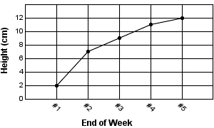

What is your prediction about the height of the plan in week 6?

- The plant’s height will increase
- The plant’s height will decrease
- The plant’s height will stay the same.

3) Look at the table below.
Fruit People chose to eat in
Week 1

Fruit | Number
Grapes | 2
Blackberries | 8
Watermelons | 11
Blueberries | 9
Coconuts | 4
Bananas | 6
Pears | 10

If the results were similar from week one to week two what two fruits do you think people would most likely eat?

- blackberries and watermelon
- blackberries and pears
- watermelons and pears
- grapes and coconuts.

