4S4 Read line graphs

Use the Line graph below to answer questions 1 and 2

Temperature at 12:00 pm
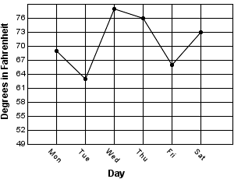

1) How much hotter was the high temperature on Saturday that it was on Friday? _________

2) What day of the week was the coolest? ________________________________________

3) Between which two days did the temperature increase the most?

4) What day of the week was the hottest? _________________________________________

5) Between which two days did the temperature decrease the most?

Use the Line graph below to answer questions 5-7.

- Between what two days did the temperature increase the most?

- Tuesday and Wednesday
- Sunday and Monday
- Friday and Saturday
- Monday and Tuesday.

- What day was the coolest day of the week?

- Sunday
- Monday
- Tuesday
- Thursday

- What question could be answered from reading this line graph?

- What day was the sun out?
- How hot was Friday?
- Was there rain on Tuesday?
- How many people voted Saturday as having the best weather?

