4S1 | Make investigation w/ given data

This is also more of a performance standard and student should conduct investigations collecting and using data but you could potentially see this standard being assessed on a standardized exam with questions like these below.

1) Look at the chart below to answer your questions.

Daneiris is training for the Olympics! He has to run in order to get in shape. The table below shows the number of miles he ran.

Miles Run
Day | Number of Miles Ran
Monday | 6
Tuesday | 8
Wednesday | 2
Thursday | 10
Friday | 7

What questions could you not answer using the data in the table above?

- How many days did Daneiris run?
- How many miles did Daneiris run?
- How many minutes did Danieris run?
- How many days did he run more than five miles?

2) Use the bar graph below to answer the question.

What question could you answer using the bar graph above?
a) At what time was the temperature the highest?
b) Between what two days did the temperature rise the most?
c) What day was the temperature 68°
d) What is the temperature on Saturday?

3) This picture graph shows the number of ice cream cones that were sold at Mel's Ice Cream Shoppe last week.
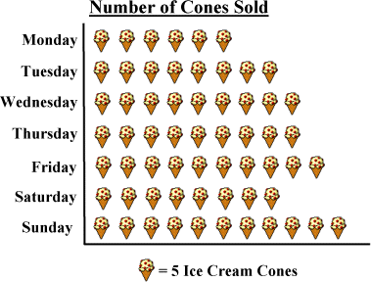

What question could you not answer by looking at the graph?

a) How many more cones were sold on Sunday that Monday?
b) How many people bought cones on Monday and Tuesday?
c) How many cones were sold on Wednesday?

