4M8 | Make change
1) Sam had a dollar. He bought a candy bar for $0.98. How much change would he get back?
- $0.02
- $0.20
- $0.12
- $2

2) Daniel has a dollar to buy a gumball from the machine. If the machine gave him back 45¢ how much did the gumball cost?

  - 45¢
  - 55¢
  - 65¢
  - $1.00

- Jennifer’s grandmother gave Jennifer $20.00 for her birthday. She bought a doll for $15.84. Calculate the change that she would receive.

$_______

4) Desiree wanted to buy a new stereo. The stereo cost $19.45. If she had twenty dollars how much change would she receive?

a. 45¢
b. 35¢
c. 55¢
d. 65¢

5) Jane had 5 dollars. She bought a hairpins at the store. If the amount below is her change how much did the hair pins cost?
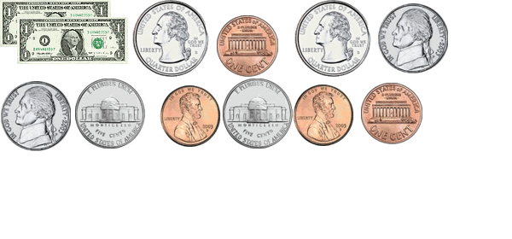

Cost of hairpins:_________________

