4M8 Make change

Draw your change. Use the fewest coins and bills.

You Have | You Spend | Your Change
$10.00 | $6.25
$6.00 | $5.19
$20.00 | $4.39
$1.00 | $.43
$ 5.00 | $3.99

- James has a twenty dollar bill. He goes to the store and buys a chocolate bar for $0.88. How much change does the cashier give him?

- Naomi wants to buy two balloons. She has one dollar. If each balloon cost 40 cents how much change would she receive if she bought two balloons?

- Count the change below.
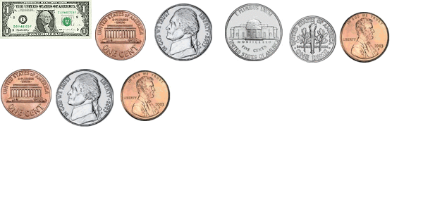

If John paid with a five dollar bill how much did the kite he bought cost?

- Hollins received a ten dollar bill from her grandmother. She bought a new dress. If the dressmaker gives her $2.59 dollars as her change how much did her dress cost?

- Shannah rode the bus from port authority to Jersey city. If she paid with a ten dollar bill and the bus driver gave her $6.50 how much did the bus ticket cost her?

