Name:____________________________

Compare quantities on a bar graph

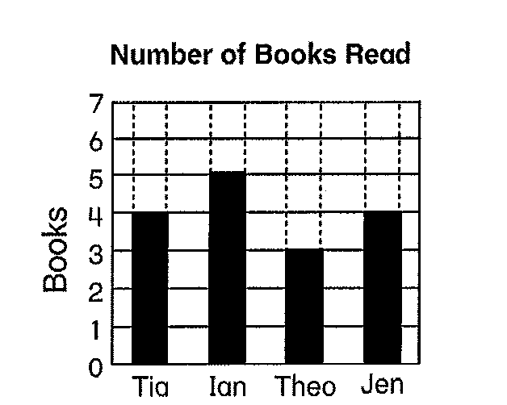

Use the graph above to answer the questions below:

1. Maximum number of books read: ___________

2. Minimum number of books read: ____________

3. Median number of books read: _____________

4. Mode number of books read: ______________

5. Person who read the most:______________

