Name:_________________

Know the values of pennies, nickels and dimes and calculate the value for combinations of these coins.

1.Add the following:




equals__________ cents

2. Add the following:
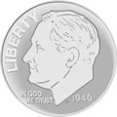

equals __________ cents

3. Add the following:

equals ____________ cents

4. Add the following:

equals ____________ cents

5. Add the following:

equals _________ cents

