MASTER MATHEMATICIANS!

- 2.M.8 Identify equivalent combinations to make up to one dollar.

Name: __________________ ______________ Date:_______________

Answer the following questions to show that you are a master mathematician! Remember, 80% or higher means you are on your way!

Draw a line to match two groups of coins that have the same value:
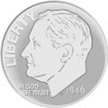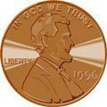 | 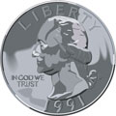
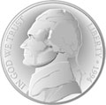

5/5 | 4/5 | 3/5 | 2/5 | 1/5 | 0/5
100% | 80% | 60% | 40% | 20% | 0%
Mastered Not Mastered

