MASTER MATHEMATICIANS!

- 2.M.6/EDM 1.c. (Secure) Know and recognize coins and bills (up to $20).

Name: __________________ ______________ Date:_______________

Answer the following questions to show that you are a master mathematician! Remember, 80% or higher means you are on your way!

Draw a line to match the coin or bill to it’s value.
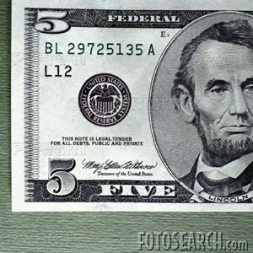 | $0.10 or 10¢
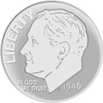 | $0.01 or 1¢
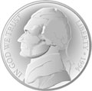 | $5.00 or 500¢
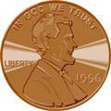 | $10.00 or 10,000¢
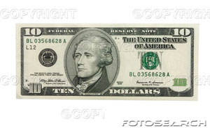 | $0.05 or 5¢

5/5 | 4/5 | 3/5 | 2/5 | 1/5 | 0/5
100% | 80% | 60% | 40% | 20% | 0%
Mastered Not Mastered

