MASTER MATHEMATICIANS!

- 1.M.4/EDM 2.d. (Secure) Know vocabulary and recognize coins (penny, nickel, dime, quarter).

Name: __________________ ______________ Date:_______________

Answer the following questions to show that you are a master mathematician! Remember, 80% or higher means you are on your way!

What coin is this?  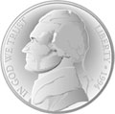  _____________________  How many cents  is it worth? ________ | What is this?  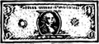  _____________________  How many cents  is it worth? ________ | What coin is this?  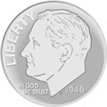  _____________________  How many cents  is it worth? ________
What coin is this?  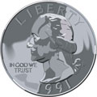  _____________________  How many cents  is it worth? ________ | What coin is this?  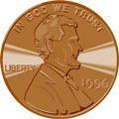  _____________________  How many cents  is it worth? ________
Word Bank

penny nickel dime quarter dollar

5/5 | 4/5 | 3/5 | 2/5 | 1/5 | 0/5
100% | 80% | 60% | 40% | 20% | 0%
Mastered Not Mastered

