Same
Venn Diagram

Connection - 2 books
Difference
t
Difference

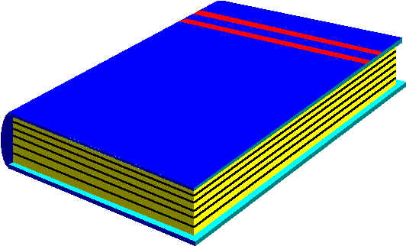
Title Title

