Pre-Kindergarten Math Exam

How many fish?
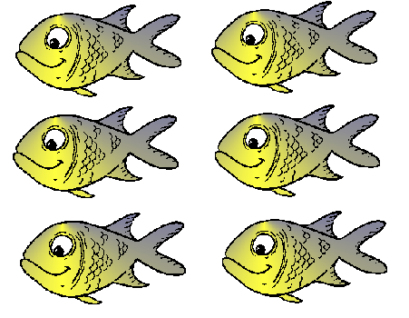_______________

Glue 5 pieces of paper to the inside of this box:
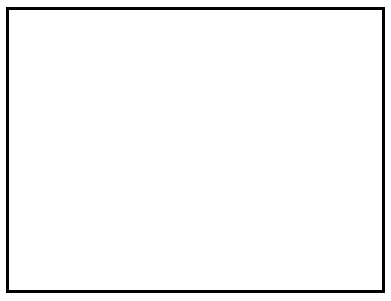

Count to 10.

Circle all of the numbers that are the same amount:
 5  9 8 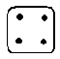

Verbal section (teacher will direct student to draw x number of “L’s”)

For every block you see, draw one X:

Say each of the numbers below:

3 0 4 1 5 2

Which horse is first and which horse is last?
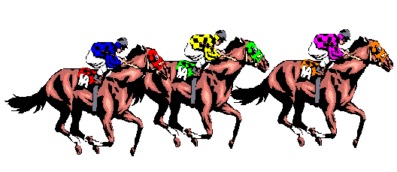

(Teacher will display up to 5 blocks)
How many blocks are there if I…
Take 1 away? ______
Add two? ______
Take 3 away? ______
Add one? ______

Create this pattern with the colored cubes.
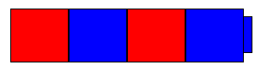
Then add three more pieces to match the pattern.

Match the shapes:


Draw a line that connects the shapes that are the same:

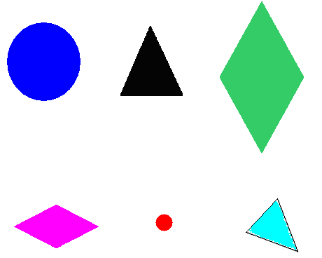

Create a tower using 8 blocks and draw a picture of it:

Draw a circle around the lion that is bigger:

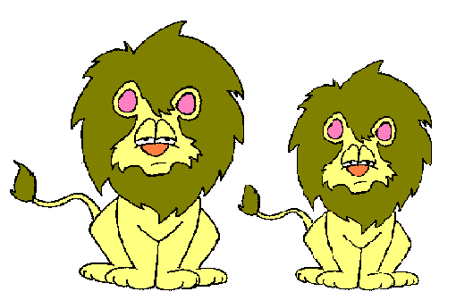

Draw a circle around the snake that is longer :

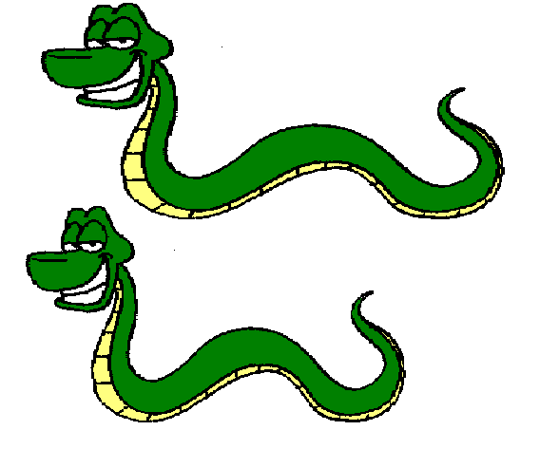

Place a sticker on the taller building:

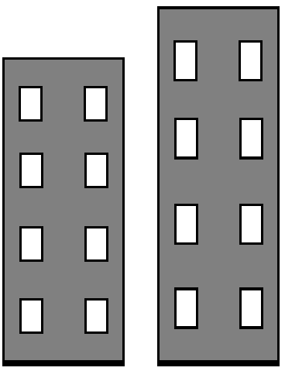

What time of day is it when you go to bed?
(Circle the answer)
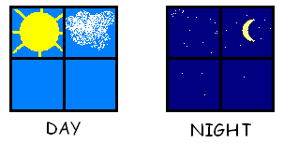

Sort the beads by color (teacher will provide up to 30 green, yellow, red and blue beads)

Make a row for each of the colors to see which color is more:
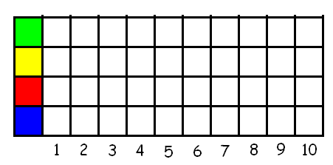

Which color has the most beads? ________
Which color has the least beads? ________

Describe the beads

Count down from 10

Put these blocks in order from biggest to smallest.

