Monday, October 17, 2005 CS57x-Crescent Elementary School

Message from Mr. Saphra to Classroom Teachers

Region 2 and Fordham Enhancing Education Through Technology Grant Title IID
Applications due: AS SOON AS POSSIBLE TO YOUR PRINCIPAL

Dear Colleagues,


We are looking for a teacher who would be interested in attending technology classes at Fordham University. Applicants need a minimum of two year’s teaching experience.

What you get:
- One 14 inch iBook wireless laptop computer
- Graduate college credit – 9 credits from Fordham Continuing Ed.
- Training Rate pay for all non-working hour classes attended

What our school gets:
- Fifteen 12 inch iBook wireless laptop computers
- One laptop cart
- Weekly visitations by pedagogical support personnel from Fordham

The schedule of classes is shown below. We will be selecting either one or the other of the two cycles. The other two teachers who have so far committed themselves to the program prefer CYCLE 5, but are flexible.

Please get in touch with Mr. Saphra for an application form or pick one up on line:

http://www.newtunings.com/teachers/fordham.doc

Yours truly,
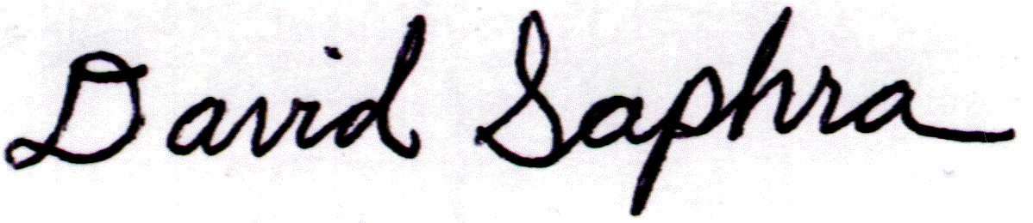

dsaphra@nycboe.net
Training Schedule:
Pick one or the other
CYCLE 4 |  |  | CYCLE 5
Fri., October 21 | Full Day |  | Fri., November 4 | Full Day
Sat., October 22 | Full Day |  | Sat., November 5 | Full Day
Thurs., November 17 | 4-6 pm |  | Thurs., December 8 | 4-6 pm
Thurs., December 15 | 4-6 pm |  | Thurs., January 26 | 4-6 pm
Fri., January 19 | Full day |  | Thurs., February 16 | 4-6 pm
Thurs., February 9 | 4-6 pm |  | Sat. March 25 | Full day
Thurs., March 9 | 4-6 pm |  | Thurs., April 6 | 4-6 pm
Sat., April 29 | Full day |  | Thurs., April 27 | 4-6 pm
Thurs., May 4 | 4-6 pm |  | Thurs., May 11 | Full day
Thurs., June 1 | 4-6 pm |  | Thurs., June 8 | 4-6 pm

