Day 1 Sub – Music / Art Lesson Plan David Saphra, Rm. 208

Aim: Make paper hats

All materials will be found on the bookshelf beyond the electronic keyboard by the window.

Materials:
Newspapers
Glue or Scotch Tape
CD with song on it by the CD player at the same location
Percussion instruments for children to play while marching around with hats singing the song when they are done

Children will have already learned the German song, “My hat it Has Three Corners” for International Day.

How To Make a Three-Cornered Paper Hat:

Start with a double sheet of newspaper folded in the middle. With the fold at the top, fold the corners down to meet in the center. It will make a triangle on top of two rectangle flaps. Fold the flap in the front up and bend the corners over. Turn the hat over and do the same thing with the other flap. Now you have a triangle. Open the hat in the middle. Push the two end points together so the middle pushes out to form a square. The bottom points on the square are now flaps. Fold the front one up so the point meets the top point of the triangle. Turn the hat over and fold up the remaining point.

http://www.kididdles.com/lyrics/m020.html

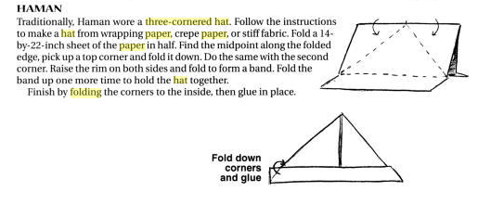

Text and Directions for song:

My Hat, It Has Three Corners

My hat, it has three corners,
Three corners has my hat
And had it not three corners,
It would not be my hat.

_____ hat, it has three corners,
Three corners has _____ hat
And had it not three corners,
It would not be _____ hat.

_____ _____, it has three corners,
Three corners has _____ _____
And had it not three corners,
It would not be _____ _____.

_____ _____, it has _____ corners,
_____ corners has _____ _____
And had it not _____ corners,
It would not be _____ _____.

_____ _____, it has _____ _____,
_____ _____ has _____ _____
And had it not _____ _____,
It would not be _____ _____.

Actions:

My - Point to self
Hat - Point to head
Three - Hold up three fingers
Corners - Bend arm and point to elbow

Omit the words in verses where "_____" is displayed, but do the corresponding actions.

Mein Hut, der hat drei Ecken,
Drei Ecken hat mein Hut.
Und hätt' er nicht drei Ecken,
So wär's auch nicht mein Hut.

