DAVID SAPHRA
9 DIVNEY LANE
IRVINGTON, NEW YORK 10533
(914) 591-2012 home / (914) 330-1884 cell
e-mail to: dsaphra@gmail.com

EXPERIENCE
2008 – Present Music cluster teacher, P.S. / I.S. 189X – Cornerstone Academy for Social Action, NYCDoE, New York, NY

- Taught music grades PreK through Grade 6
- Created chant for teaching CASA School’s core values as well as a blues-style version for older students
- Produced and distributed monthly sing-along audio CDs to all classroom teachers with lyrics sheets
- Devised home-made instrument kits complete with materials and instructions as rewards for good behavior
- Started up school’s chess club and taught game to beginners 1st grade through 4th grade during extended day
- Assisted with production and documentation of assembly programs and Moving Up ceremonies
- Set up web site: corner189.com

2007 – 2009 Music cluster teacher, P.S. 146X , New York City Board of Education, New York, N.Y.

- Applied for Music and the Brain grant and implemented use of music lab with 28 keyboards
- Set up instrumental music recorder program funded by parental contributions, created take-home materials
- Created teacher-friendly school web site: ps146x.googlepages.com with web pages for all classes
- Wrote school song, “PS146.US,” as a means of promoting use of the school web site
- Trained choir to sing song specially written for awards assembly, “Give them a Hand”
- Created chant for Positive Behavioral Intervention Support event and taught it at school-wide gatherings
- Awarded funding for two separate DonorsChoose proposals

2001-2007 Technology Specialist / Music Cluster, C.S. 57X , New York City Board of Education, New York, N.Y.

- Taught music classes grades Pre-K through 2nd Grade utilizing combined Kódaly / Orff approach
- Taught music literacy using through hands-on use of computer software, Grades 3 - 5
- Composed school song and taught it to all age levels: newtunings.com/57/schoolsong.html
- Created and presented annually a pep rally song to help combat testing anxiety: “I Like to Take a Test”
- Organized Chess Club, at first independently and then together with Chess-in-the-Schools program
- Field Trip Coordinator - integrated planning of trips and scheduling of buses with the school web site
- Designed and maintained school web site: newtunings.com/57/orient/central.htm

1991-2001 Music cluster teacher, C.S. 134X , New York City Board of Education, New York, N.Y.

- Designed transparencies and miniature song booklets for use at school-wide sight-reading sing-alongs
- Conducted in-house workshops for colleagues and parents at the Teacher Center
- Created extensive, highly trafficked web site resource for music educators: www.kidmid.com
- Distributed freeware programs for composing music, creating math and word puzzles and playing chess
- Devised numerous activity sheets utilizing word and math puzzles to promote the learning of song lyrics
- Composed and taught school song, “Hidden on a Little Street in the Bronx”

1987-1991 Music Cluster teacher, CS 234X, New York City Board of Education, New York, N.Y.

- Composed and helped student’s learn theme song for Bank Street College’s “Healthy Choices” video
- Devised musical substance abuse unit to feed into Drug-Free Day including song “No Drugs March”
- Led staff-development sessions teaching techniques for making home-made musical instruments that were duplicated by classroom teachers and students

1986 -1987 Classroom teacher, PS 197M, New York City Board of Education, New York, N.Y.
- Taught grade 4, standard grade school curriculum.

1984 -1986 Classroom teacher, PS 129M, New York City Board of Education, New York, N.Y.
- Taught grade 2, standard curriculum
- Taught grade 4, talented and gifted program, accelerated curriculum.

EDUCATION M.S. in Elementary Education, Hofstra University, Hempstead, New York, 1983.
M.A. in Music, University of Nebraska, Lincoln, Nebraska, 1981.
B.F.A. in Music, State University of New York, Purchase, New York, 1977

TEACHING New York City Common Branch license, Day Elementary School
LICENSES New York State Music, K-12
OPEN MARKET APPLICATION ELECTRONIC COVER LETTER

DAVID SAPHRA
9 DIVNEY LANE
IRVINGTON, NEW YORK 10533
(914) 591-2012 home / (914) 330-1884 cell
e-mail to: dsaphra@gmail.com

Dear Administrator,

I am currently seeking a position teaching music, PreK-12. I have worked for the NYCDoE for over twenty-four years with a variety of age groups, having been satisfactorily employed under a Common Branches license for this entire period. I also hold a NYS Music license and have extensive experience teaching both vocal and instrumental music as well as methods for using technology to create music. Having worked as both music teacher and technology specialist, I would especially welcome an opportunity that might also allow for utilization of my technology expertise. I maintain an active account with NYCDoE’s technology “Magic” trouble-shooting support system and have developed techniques for utilizing the system to best advantage.

During most of my career I have taught music literacy through singing repertoire utilizing a hybrid of Kodály and Orff methodologies along with the many song and movement activities I have personally created. I often use guitar to accompany children's singing which tends to be less overpowering and allows for great flexibility traveling around the building.

I especially enjoy working together with teachers and parents to help prepare students for actual performance situations including off-site public performances and audio / video recordings for upload to the internet. I have always aggressively promoted use of a school website for regular display of student accomplishment.

I aim to commit to my new assignment as soon as possible in order to take full advantage of the summer to prepare for the fall. I look forward to hearing from you at your earliest possible convenience.

Yours truly,
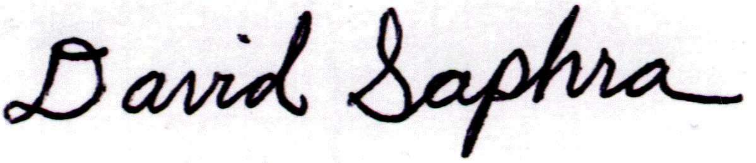
David Saphra

