David Saphra's Bio
Also, please send a bio (written in the third person and maximum of 200 words) and a picture to be included in the 'who's who' handout for fellow participants.

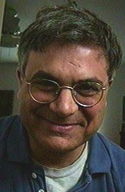
David Saphra was born in 1951 and grew up in Levittown where he learned to play the guitar by the age of eight. got his start in music as a

