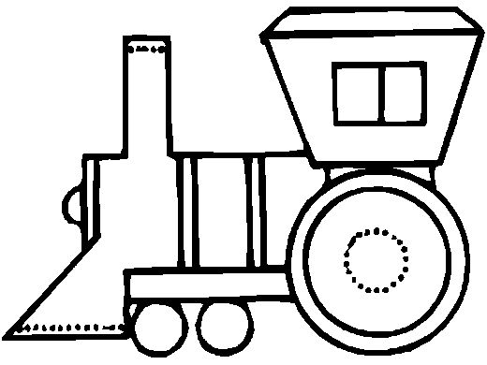
9
9
9
9

Engine, Engine Number Nine
9
9
9
9

Going down the railroad line
9
9
9
9

If the train goes off the track
9
9
9
9

Do you want your money back?

