MAGIC PENNY by Malvina Reynolds
d
r
d
r
d

Love is something if you give it away,
Give it away, give it away.
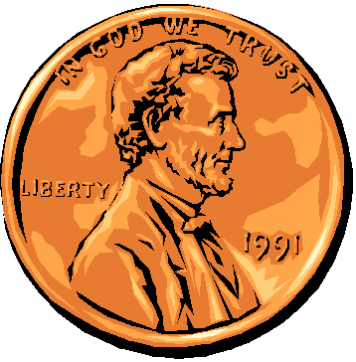
Love is something if you give it away,
You end up having more.
d
s
f
f
m
r

It's just like a magic penny,
Hold it tight and you won't have any.

Lend it, spend it,
and you'll have so many
They'll roll all over the floor, for:

Love is something if you give it away,
Give it away, give it away.
Love is something if you give it away,
You end up having more.

So let's go dancing till the break of day,
And if there's a piper, we can pay.
For love is something if you give it away,
You end up having more.

For love is something if you give it away,
Give it away, give it away.
Love is something if you give it away,
You end up having more.

