BIG OLD STORM A-COMIN’
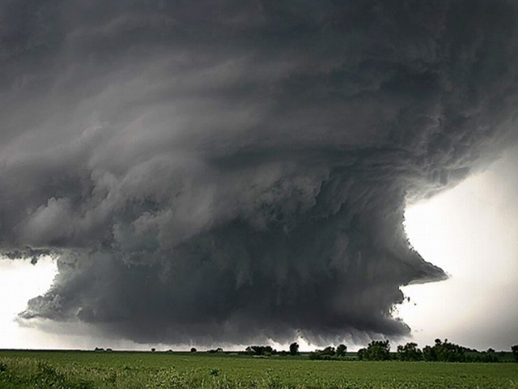
There’s a big old storm a comin’
Big old storm tonight
There’s a big old storm a comin’
Better shut your windows tight

There’s rain, rain, raindrops fallin’
Rain, rain, rain tonight
There’s rain, rain, raindrops fallin’
Better shut your windows tight

THE RAINBOW

After the rain is the rainbow

After the rain, then the sun comes out again
After the rain is the rainbow
Pretty rainbow in the sky

Rainbows are telling a story
Rainbows are saying,
“The sun comes out again.”
After the rain is the rainbow
Pretty rainbow in the sky

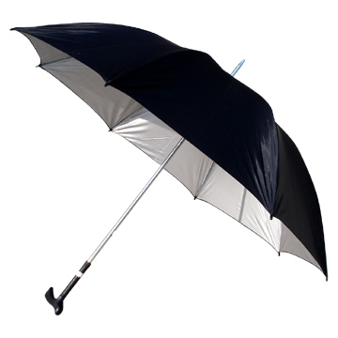
DOCTOR KATCHEL

Doctor Katchel, with his satchel
Through the rain the doctor goes
Splishy splashy, squishy squashy
He makes music with his toes

[Spoken]
Doctor, Doctor,
quick, quick, quick
Give her some medicine
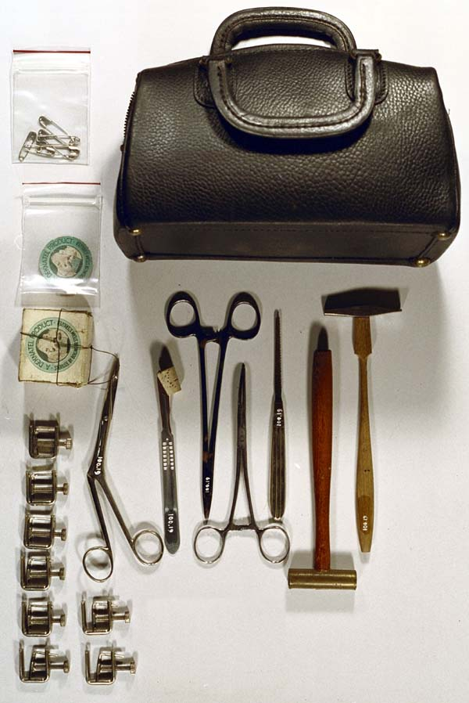
She looks sick

