You Take a Stick of Bamboo

||: You take a stick of bamboo
You take a stick of bamboo
You take a stick of bamboo
And you put it in the water
Oh-oh, oh-oh, Hannah :||

||: River, river, she come down :||

||: You travel on the river
You travel on the river
You travel on the river
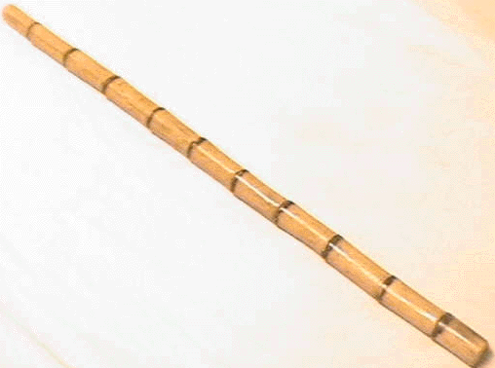
Oh, you travel on the water
Oh-oh, oh-oh, Hannah :||

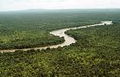
||: River, river, she come down :||

||: My home’s across the river
My home’s across the river
My home’s across the river
My home’s across the water
Oh-oh, oh-oh, Hannah :||

||: River, river, she come down :||

||: You take a stick of bamboo
You take a stick of bamboo
You take a stick of bamboo
And you put it in the water
Oh-oh, oh-oh, Hannah :||

||: River, river, she come down :||

