



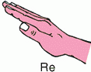

Considerate
Be Considerate
Be Accountable
Be Respectful
Be Empowered
Be Successful

