SCHOOL’S ALMOST OVER by Mr. Saphra © 2007

School’s almost over
We’re nearly done
Summer is coming
Let’s have some fun
Let’s get together
With all our friends
Let’s get together when
the school year ends
Lala lala lala lalaa laa laa

Though there were hard times
We always knew
Who we could turn to
And make it through
Then pull together
With all your friends
Let’s get together when
the school year ends
Lala lala lala lalaa laa laa

So don’t you cry now
No don’t be sad
Don’t say good by now
We’ll all be glad
When we’re together
With all our friends
Let’s get together when the school year ends
Let’s get together when the school year ends
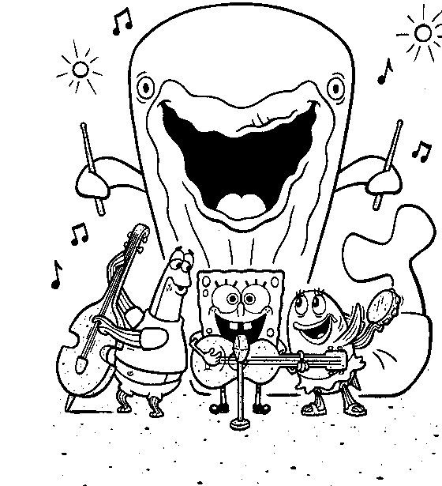
corner189.com

SCHOOL’S ALMOST OVER by Mr. Saphra © 2007

School’s almost over
We’re nearly done
Summer is coming
Let’s have some fun
Let’s get together
With all our friends
Let’s get together when
the school year ends
Lala lala lala lalaa laa laa

Though there were hard times
We always knew
Who we could turn to
And make it through
Then pull together
With all your friends
Let’s get together when
the school year ends
Lala lala lala lalaa laa laa

So don’t you cry now
No don’t be sad
Don’t say good by now
We’ll all be glad
When we’re together
With all our friends
Let’s get together when the school year ends
Let’s get together when the school year ends
corner189.com

SCHOOL’S ALMOST OVER by Mr. Saphra © 2007

School’s almost over
We’re nearly done
Summer is coming
Let’s have some fun
Let’s get together
With all our friends
Let’s get together when
the school year ends
Lala lala lala lalaa laa laa

Though there were hard times
We always knew
Who we could turn to
And make it through
Then pull together
With all your friends
Let’s get together when
the school year ends
Lala lala lala lalaa laa laa

So don’t you cry now
No don’t be sad
Don’t say good by now
We’ll all be glad
When we’re together
With all our friends
Let’s get together when the school year ends
Let’s get together when the school year ends
corner189.com

SCHOOL’S ALMOST OVER by Mr. Saphra © 2007

School’s almost over
We’re nearly done
Summer is coming
Let’s have some fun
Let’s get together
With all our friends
Let’s get together when
the school year ends
Lala lala lala lalaa laa laa

Though there were hard times
We always knew
Who we could turn to
And make it through
Then pull together
With all your friends
Let’s get together when
the school year ends
Lala lala lala lalaa laa laa

So don’t you cry now
No don’t be sad
Don’t say good by now
We’ll all be glad
When we’re together
With all our friends
Let’s get together when the school year ends
Let’s get together when the school year ends
corner189.com

WASH YOUR HANDS © D.Saphra 1997

Wash your hands,
wash your hands
Make those germs
all go away
Wash your hands, wash your hands
Do it every day

There once was a little girl
Who forgot to
wash her hands
Now she’s coughing
[cough, cough]
Now she’s sneezing
[a-choo!]
Why did it have to be this way?
You know what to say: [Chorus]

There once was a little boy
Who didn’t want
to wash his hands
Now instead of
putting on his coat
He’s stuck in bed with
a bad sore throat
Everyone take note: [Chorus]

Now we’re such
happy children
We always wash our hands
Learn this lesson
Learn it quick
If you don’t want to get sick
It’s such a simple trick [Chorus]
WASH YOUR HANDS © D.Saphra 1997

Wash your hands,
wash your hands
Make those germs
all go away
Wash your hands, wash your hands
Do it every day

There once was a little girl
Who forgot to
wash her hands
Now she’s coughing
[cough, cough]
Now she’s sneezing
[a-choo!]
Why did it have to be this way?
You know what to say: [Chorus]

There once was a little boy
Who didn’t want
to wash his hands
Now instead of
putting on his coat
He’s stuck in bed with
a bad sore throat
Everyone take note: [Chorus]

Now we’re such
happy children
We always wash our hands
Learn this lesson
Learn it quick
If you don’t want to get sick
It’s such a simple trick [Chorus]
WASH YOUR HANDS © D.Saphra 1997

Wash your hands,
wash your hands
Make those germs
all go away
Wash your hands, wash your hands
Do it every day

There once was a little girl
Who forgot to
wash her hands
Now she’s coughing
[cough, cough]
Now she’s sneezing
[a-choo!]
Why did it have to be this way?
You know what to say: [Chorus]

There once was a little boy
Who didn’t want
to wash his hands
Now instead of
putting on his coat
He’s stuck in bed with
a bad sore throat
Everyone take note: [Chorus]

Now we’re such
happy children
We always wash our hands
Learn this lesson
Learn it quick
If you don’t want to get sick
It’s such a simple trick [Chorus]
WASH YOUR HANDS © D.Saphra 1997

Wash your hands,
wash your hands
Make those germs
all go away
Wash your hands, wash your hands
Do it every day

There once was a little girl
Who forgot to
wash her hands
Now she’s coughing
[cough, cough]
Now she’s sneezing
[a-choo!]
Why did it have to be this way?
You know what to say: [Chorus]

There once was a little boy
Who didn’t want
to wash his hands
Now instead of
putting on his coat
He’s stuck in bed with
a bad sore throat
Everyone take note: [Chorus]

Now we’re such
happy children
We always wash our hands
Learn this lesson
Learn it quick
If you don’t want to get sick
It’s such a simple trick [Chorus]

