HOW DO I LIVE WITHOUT YOU?

How do I,
Get through one night without you,
If I had to live without you,
What kinda life would that be

Oh I, I need in my arms,
need you to hold,
Your my world, my heart, my soul,
If you ever leave,
Baby you would take away everything
good in my life

And tell me now,
How do I live without you?
I want to know,
How do I breathe without you?
If you ever go,
How do I ever, ever survive,
How do I, how do I, oh, how do I live?

Without you,
There'd be no sun in my sky,
There would be no love in my life,
There'd be no world left for me

And I,
Baby I don't know what I would do,
I would be lost,
If I lost you,
If you ever leave,
Baby you would take away everything
real in my life
Movin' on Up
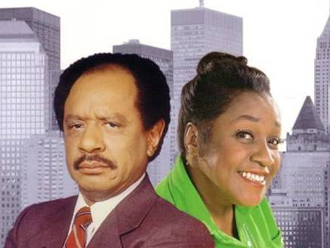
[Theme from The Jeffersons]
Well we're movin on up,
To the east side.
To a deluxe apartment
in the sky.
Movin on up,
To the east side.
We finally got a piece of the pie.
Fish don't fry in the kitchen;
Beans don't burn on the grill.
Took a whole lotta tryin',
Just to get up that hill.
Now we're up in the big leagues,
Gettin' our turn at bat.
As long as we live,
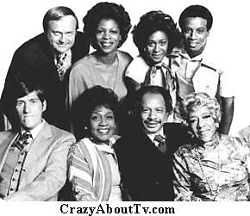
it's you and me baby,
There ain't nothin
wrong
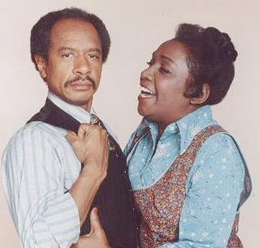
with that.
Well we're movin on up,
To the east side.
To a deluxe apartment
in the sky.
Movin on up,
To the east side.
We finally got a piece of the pie.
HOW DO I LIVE WITHOUT YOU?

