SCHOOL’S ALMOST OVER by Mr. Saphra © 2007

School’s almost over
We’re nearly done
Summer is coming
Let’s have some fun
Let’s get together
With all our friends
Let’s get together when
the school year ends
Lala lala lala lalaa laa laa

Though there were hard times
We always knew
Who we could turn to
And make it through
Then pull together
With all your friends
Let’s get together when
the school year ends
Lala lala lala lalaa laa laa

So don’t you cry now
No don’t be sad
Don’t say good by now
We’ll all be glad
When we’re together
With all our friends
Let’s get together when the school year ends
Let’s get together when the school year ends
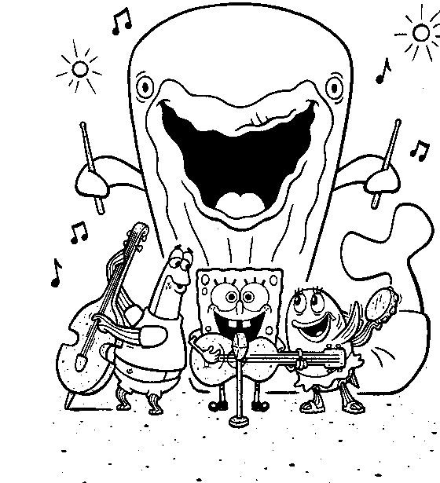

SCHOOL’S ALMOST OVER by Mr. Saphra © 2007

School’s almost over
We’re nearly done
Summer is coming
Let’s have some fun
Let’s get together
With all our friends
Let’s get together when
the school year ends
Lala lala lala lalaa laa laa

Though there were hard times
We always knew
Who we could turn to
And make it through
Then pull together
With all your friends
Let’s get together when
the school year ends
Lala lala lala lalaa laa laa

So don’t you cry now
No don’t be sad
Don’t say good by now
We’ll all be glad
When we’re together
With all our friends
Let’s get together when the school year ends
Let’s get together when the school year ends

SCHOOL’S ALMOST OVER by Mr. Saphra © 2007

School’s almost over
We’re nearly done
Summer is coming
Let’s have some fun
Let’s get together
With all our friends
Let’s get together when
the school year ends
Lala lala lala lalaa laa laa

Though there were hard times
We always knew
Who we could turn to
And make it through
Then pull together
With all your friends
Let’s get together when
the school year ends
Lala lala lala lalaa laa laa

So don’t you cry now
No don’t be sad
Don’t say good by now
We’ll all be glad
When we’re together
With all our friends
Let’s get together when the school year ends
Let’s get together when the school year ends

SCHOOL’S ALMOST OVER by Mr. Saphra © 2007

School’s almost over
We’re nearly done
Summer is coming
Let’s have some fun
Let’s get together
With all our friends
Let’s get together when
the school year ends
Lala lala lala lalaa laa laa

Though there were hard times
We always knew
Who we could turn to
And make it through
Then pull together
With all your friends
Let’s get together when
the school year ends
Lala lala lala lalaa laa laa

So don’t you cry now
No don’t be sad
Don’t say good by now
We’ll all be glad
When we’re together
With all our friends
Let’s get together when the school year ends
Let’s get together when the school year ends

