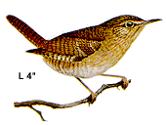
One Little Brown Bird

1
2
3
4
5

One little brown bird, up and up he flew
Along came another one and that made two

Two little brown birds, sitting in a tree
Along came another one and that made three

Three little brown birds, then up came one more
Along came another one and that made four

Four little brown birds, all alive, alive
Along came another one and that made five
Five little brown birds, sitting on some sticks
6
7
8
9
10

Along came another one and that made six

Six little brown birds, flying up to heaven
Along came another one and that made seven

Seven little brown birds, sitting on a gate
Along came another one and that made eight

Eight little brown birds, sat on mother’s line
Along came another one and that made nine

Nine little brown birds, up they flew again
Then home they flew to Father Bird and that made ten

