Mother’s Day Song #2
by Edna Strauss

Mother does so much for us
Every day of the year
I’d love to surprise her
Now that Mother’s Day is here
I’ll make a pretty card and
We’ll give Mom a day of rest
And we’ll find her some flowers
For Mom deserves the best
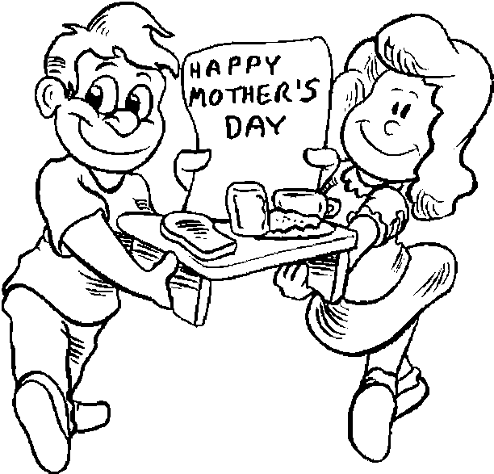

Thank You for Being Our Mother
by Mr. Saphra

Mother’s Day is very near
We’re getting a chance to tell you
Getting a chance for you to hear
Thank you for being our mother
Thank you now, for all you’ve done
All the happiness, all the fun
Thank you now for always being
Our Mother, dear

