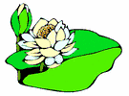
THERE’S A LITTLE WHITE DUCK

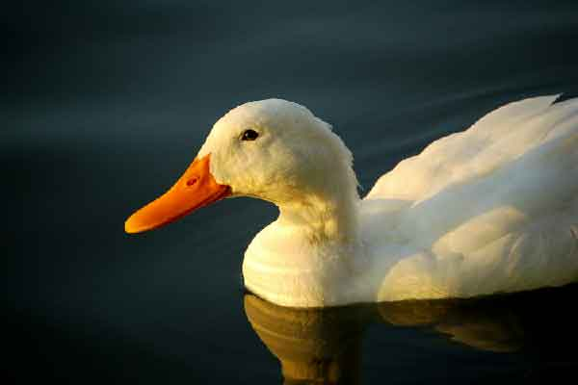
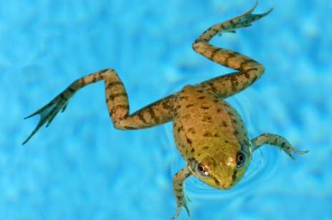
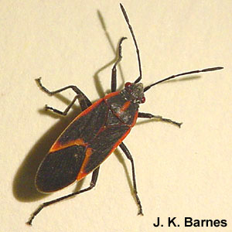
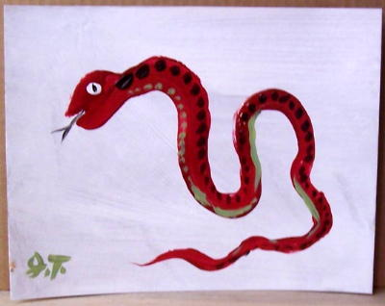
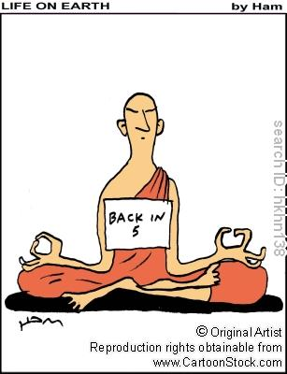
There's a little white duck sitting in the water
A little white duck doing what he oughter (ought to)
He took a bite of a lily pad
He flapped his wings and he said "I'm glad
I'm a little white duck sitting in the water
Quack! quack! quack!"
There's a little green frog swimming in the water
A little green frog doing what he oughter
he jumped right off of the lily pad
that the little duck bit and he said "I'm glad
I'm a little green frog swimming in the water
Glug, glug, glug!"
There's a little black bug floating on the water
A little black bug doing what he oughter
He tickled the frog on the lily pad
That the little duck bit and he said "I'm glad
I'm a little black bug floating on the water
Bzzz! bzzz! bzzz!"
There's a little red snake playing in the water
A little red snake doing what he oughter
He frightened the duck and the frog so bad
He ate the bug and he said "I'm glad
I'm a little red snake playing in the water
Hiss! hiss! hiss!"
Now there's nobody left sitting in the water
There’s nobody left doing what he oughter
There's nothing left but the lily pad
The duck and the frog ran away, I'm sad
'Cause there's nobody left sitting in the water
Boo! hoo! hoo!

