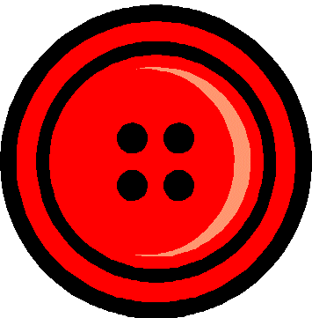
Button, You Must Wander
Button, you must wander , wander, wander
Button you must wander everywhere
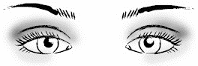
Bright eyes will find you
Sharp eyes will find you
Button you must wander everywhere

