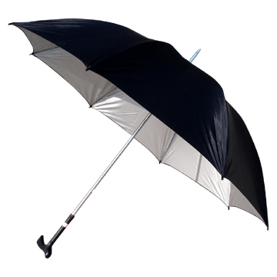
DOCTOR KATCHEL

Doctor Katchel, with his satchel
Through the rain the doctor goes
Splishy splashy, squishy squashy
He makes music with his toes

[Spoken]
Doctor, Doctor,
quick, quick, quick
Give her some medicine
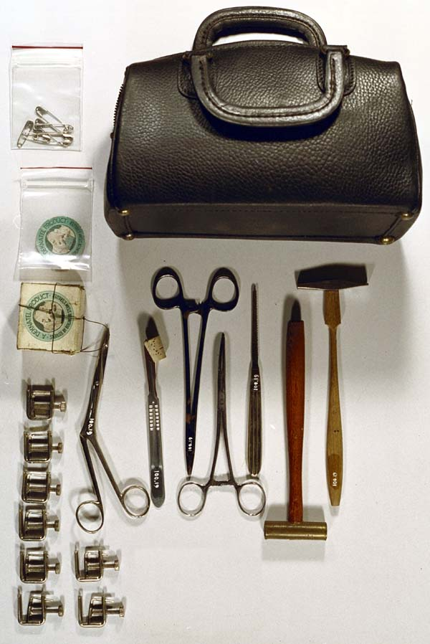
She looks sick
How to make a rain clap:

- Make a cup with one hand
- Join two fingers together with the other hand
- Smack the your two fingers to the beat into the cupped hand
- Don’t stop until the song is over

