MUST BE SANTA
corner189.com
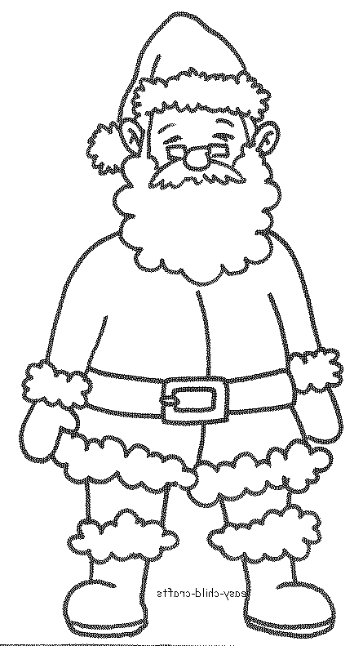
Who's got a beard
that's long and white?
Santa's got a beard
that's long and white.

Who comes around
on a special night?
Santa comes around
on a special night.

Special night, beard that's white,

Must be Santa must be Santa,
Must be Santa, Santa Claus.

Who wears boots and a suit of red?
Santa wears boots and a suit of red.

Who wears a long cap on his head?
Santa wears a long cap on his head.

Cap on head, suit that's red,
Special night, beard that's white,

Must be Santa must be Santa,
Must be Santa, Santa Claus.

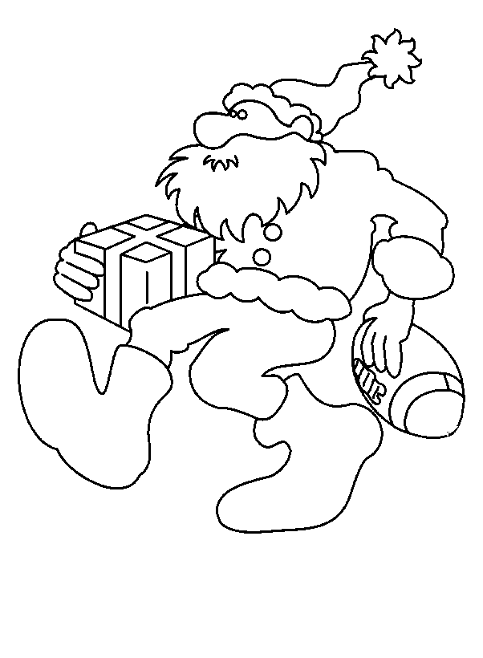
Who's got a big red cherry nose?
Santa's got a big red cherry nose.

Who laughs this way:
HO HO HO?

Santa laughs this way:
HO HO HO!

HO HO HO, cherry nose,
Cap on head, suit that's red,
Special night, beard that's white,

Must be Santa must be Santa,
Must be Santa, Santa Claus.

Who very soon will come our way?
Santa very soon will come our way.

Eight little reindeer pull his sleigh,
Santa's little reindeer
pull his sleigh.

Reindeer sleigh, come our way,
HO HO HO, cherry nose,
Cap on head, suit that's red,
Special night, beard that's white,

Must be Santa, must be Santa,
Must be Santa, Santa Claus.

Dasher, Dancer, Prancer, Vixen,
Comet, Cupid, Donner and Blitzen.

Reindeer sleigh, come our way,
HO HO HO, cherry nose,
Cap on head, suit that's red,
Special night, beard that's white,

Must be Santa, must be Santa,
Must be Santa, Santa Claus!
MUST BE SANTA
corner189.com
Who's got a beard
that's long and white?
Santa's got a beard
that's long and white.

Who comes around
on a special night?
Santa comes around
on a special night.

Special night, beard that's white,

Must be Santa must be Santa,
Must be Santa, Santa Claus.

Who wears boots and a suit of red?
Santa wears boots and a suit of red.

Who wears a long cap on his head?
Santa wears a long cap on his head.

Cap on head, suit that's red,
Special night, beard that's white,

Must be Santa must be Santa,
Must be Santa, Santa Claus.

Who's got a big red cherry nose?
Santa's got a big red cherry nose.

Who laughs this way:
HO HO HO?

Santa laughs this way:
HO HO HO!

HO HO HO, cherry nose,
Cap on head, suit that's red,
Special night, beard that's white,

Must be Santa must be Santa,
Must be Santa, Santa Claus.

Who very soon will come our way?
Santa very soon will come our way.

Eight little reindeer pull his sleigh,
Santa's little reindeer
pull his sleigh.

Reindeer sleigh, come our way,
HO HO HO, cherry nose,
Cap on head, suit that's red,
Special night, beard that's white,

Must be Santa, must be Santa,
Must be Santa, Santa Claus.

Dasher, Dancer, Prancer, Vixen,
Comet, Cupid, Donner and Blitzen.

Reindeer sleigh, come our way,
HO HO HO, cherry nose,
Cap on head, suit that's red,
Special night, beard that's white,

Must be Santa, must be Santa,
Must be Santa, Santa Claus!

