If You Miss me at the Back of the Bus
You can't find me nowhere, oh-oh-oh
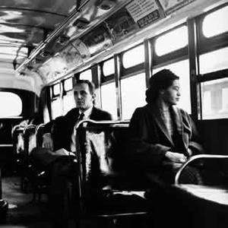
Come on over to the front of the bus
I'll be riding right there
I'll be riding right there,
I'll be riding right there
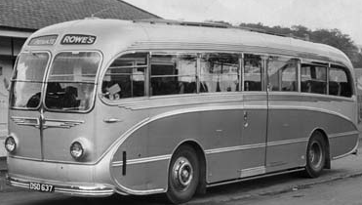
Come on over to the front of the bus
Because I'll be riding up there
If you miss me on the picket line
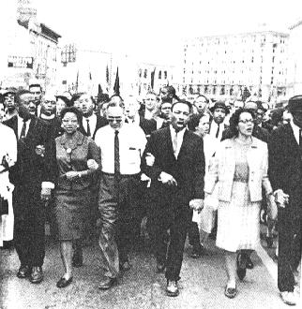
You can't find me nowhere
Come on over to the city jail
I'll be rooming over there
I'll be rooming over there
I'll be rooming over there, oh-oh-oh
Come on over to the city jail
Because I'll be rooming over there
If you miss me at the Mississippi river
You can't find me nowhere
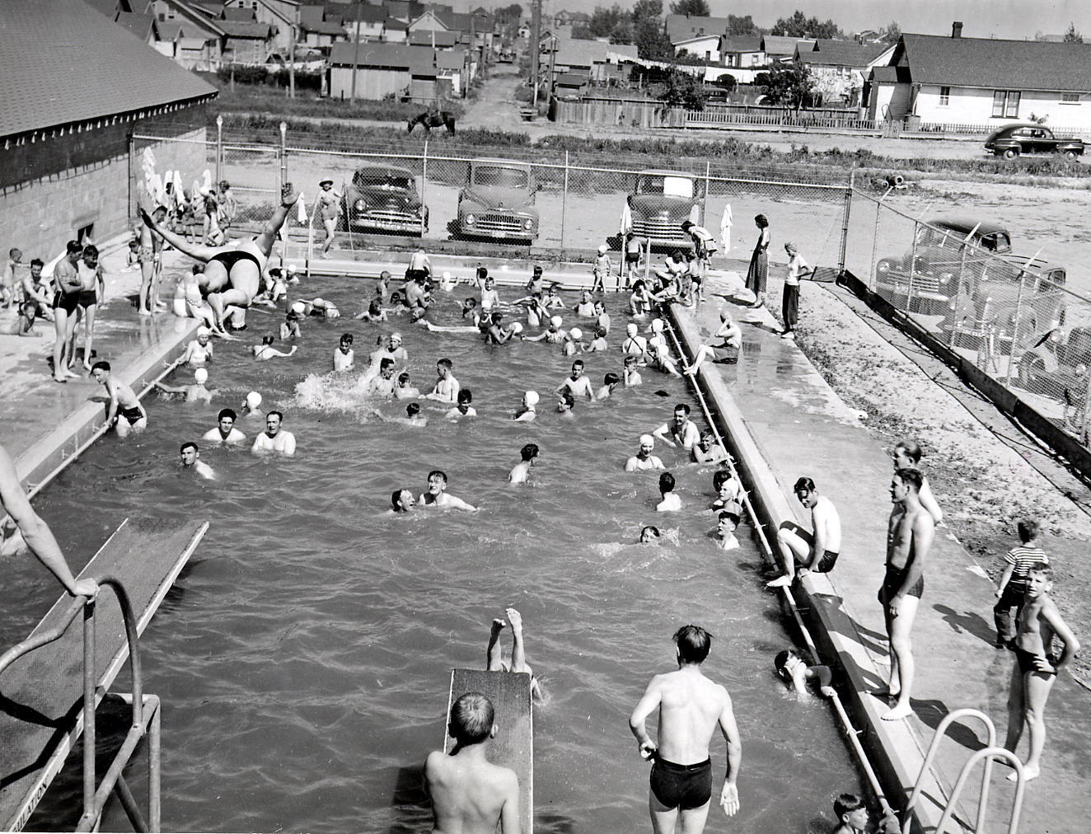
Come on over to the swimming pool
I'll be swimming over there
I'll be swimming over there
I'll be swimming over there, oh-oh-oh
Come on over to the swimming pool
Because I'll be swimming over there
If you miss me in the cotton fields
You can't find me nowhere
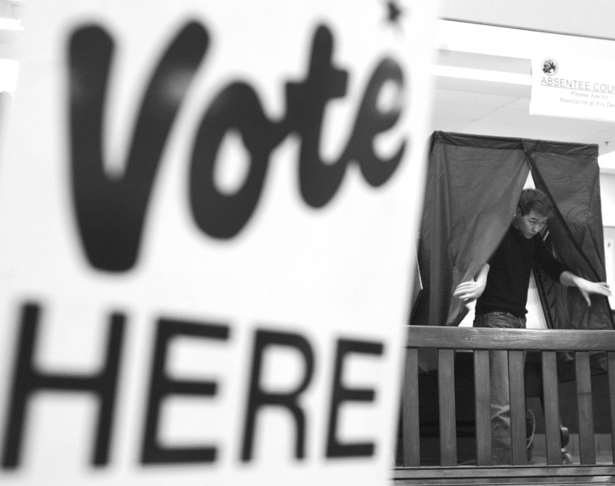
Come on over to tthe voting booth
I'll be a voting right there
I'll be voting right there
I'll be voting right there, oh-oh-oh
Well come on over to the voting booth
Because I'll be voting right there

