Songs for CASA Assemblies #3 & #4
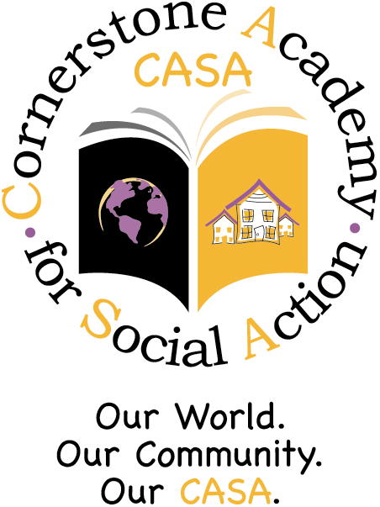
Nov. 26, 2008
&
Dec. 23, 2008

1. The Star-Spangled Banner – w/vocals
2. The Star-Spangled Banner – no vocals
3. Lift Every Voice and Sing
4. Thank You Song
5. The Holiday Spirit w/vocals
6. The Holiday MIDI (no vocals)
7. Come, Kwanzaa! (no vocals)
8. Chicken Dance
9. Turkey Dance

10. Grateful (Paul Simon)
11. Go Out and Vote – w/vocals
12. Go Out and Vote – no vocals
13. I Like to Take a Test
14. Des Colores
15. Peacemakers
16. Hasta la Vista

All songs linked on the Music Corner:
www.corner189.com

